Project Report Format

# INTRODUCTION

* 1. Project Overview
  2. Purpose of the Project

# IDEATION PHASE

* 1. Problem Statement
  2. Empathy Map Canvas
  3. Brainstorming

# REQUIREMENT ANALYSIS

* 1. Customer Journey map
  2. Solution Requirement
  3. Data Flow Diagram
  4. Technology Stack

# PROJECT DESIGN

* 1. Problem Solution Fit
  2. Proposed Solution
  3. Solution Architecture

# PROJECT PLANNING & SCHEDULING

* 1. Project Planning

# FUNCTIONAL AND PERFORMANCE TESTING

* 1. Performance Testing

# RESULTS

7.1 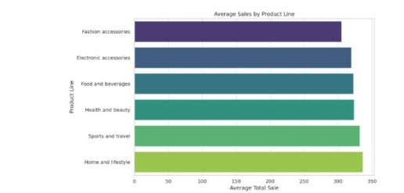

# ADVANTAGES & DISADVANTAGES

* 1. **Advantages**

1. Weight Management
2. Improved Health

# 8.2 Disadvantages

1. Nutritional Deficiencies
2. Short-Term Focus

# CONCLUSION

Dieting, when approached wisely and sustainably, can significantly improve overall health, help manage weight, and reduce the risk of chronic diseases. However, extreme or poorly planned diets can lead to nutritional deficiencies, mental stress, and unsustainable habits.

# FUTURE SCOPE

The **future scope** of any field or initiative reflects its **potential for growth, innovation, and impact**. Whether you're discussing technology, education, healthcare, artificial intelligence, or personal development, the future holds promising opportunities fueled by ongoing research, advancements, and evolving societal needs.

1. **APPENDIX**

Source Code (Tableau)

GitHub Link : https://github.com/vishnudel/comperhensive-analysis-and-dietary-strtergies-with-tableau.git

Demo Link :